  lAB7  Combinational Logic  Name : 黃翊宏 Student ID : 01357101 |  | Note  - All files must be converted to PDF format before submission.  Submission deadline: Next Tuesday at 1:00 PM  Each person submits one assignment.

※Please use Win + Shift + S for screenshots. Do not take photos of the screen.
- Lab 7-1：

Main Code Screenshot
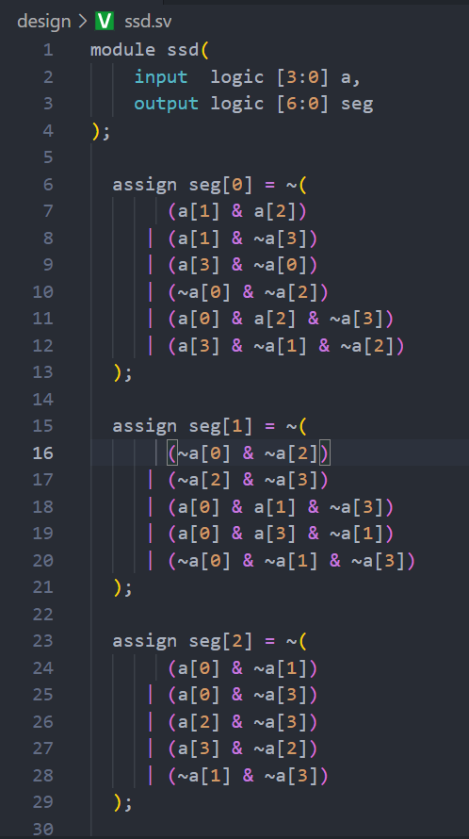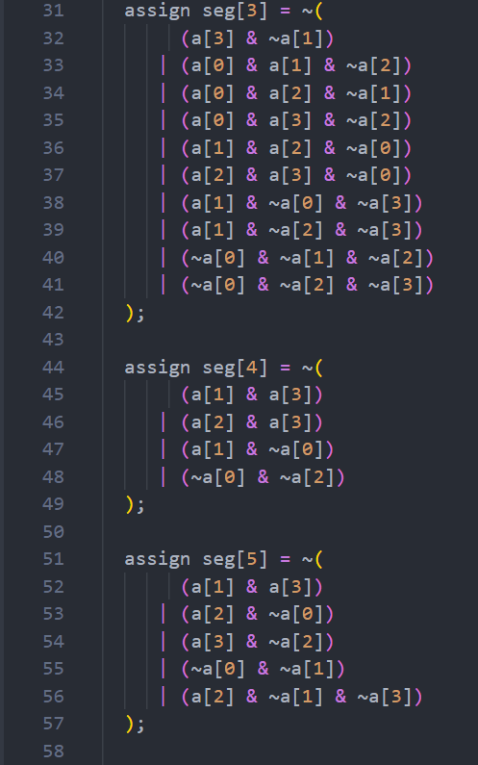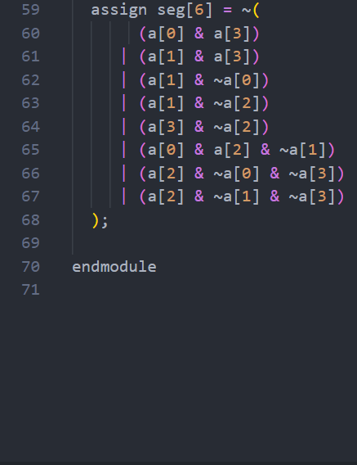
Testbench Screenshot
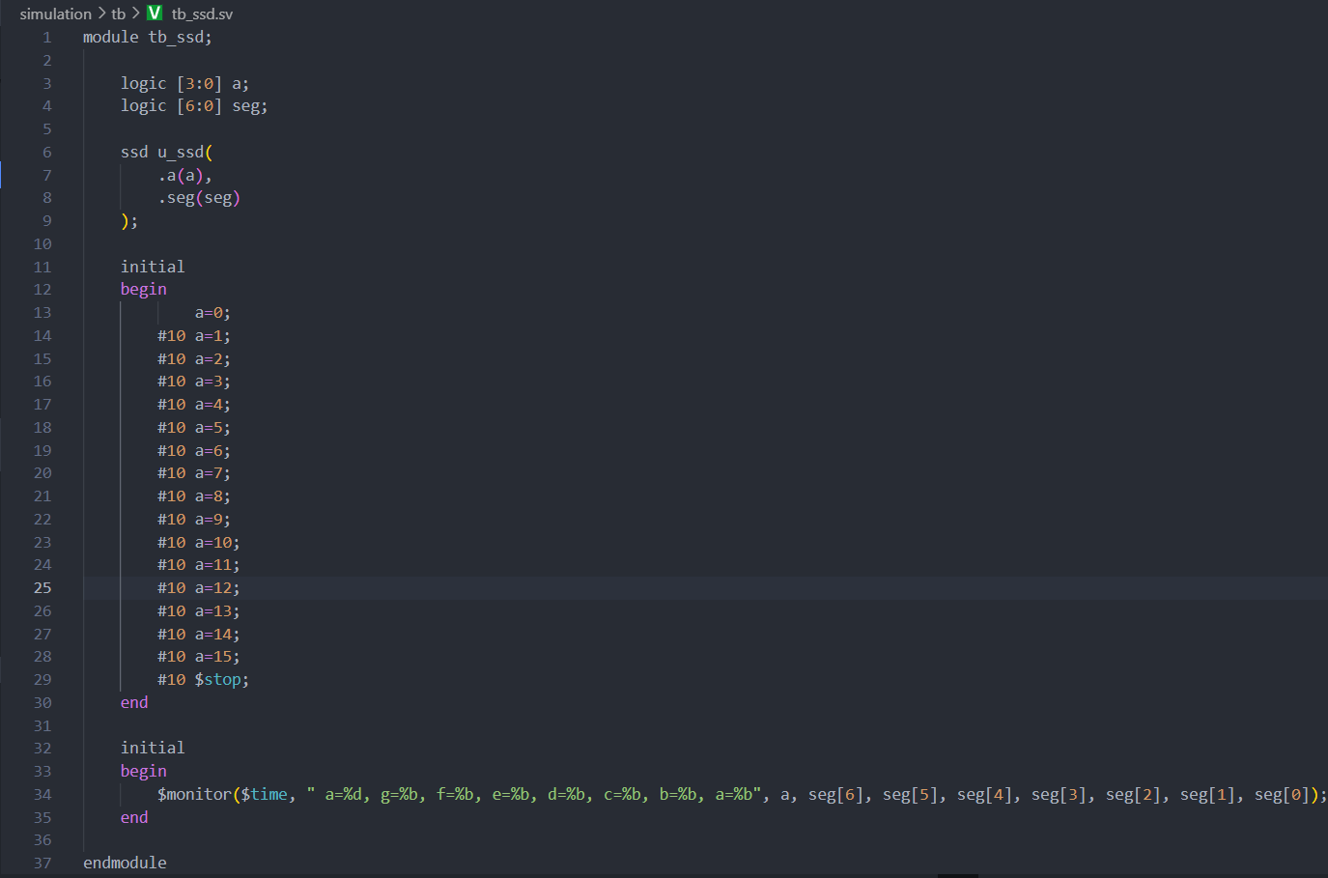
Mcu.sv Code Screenshot
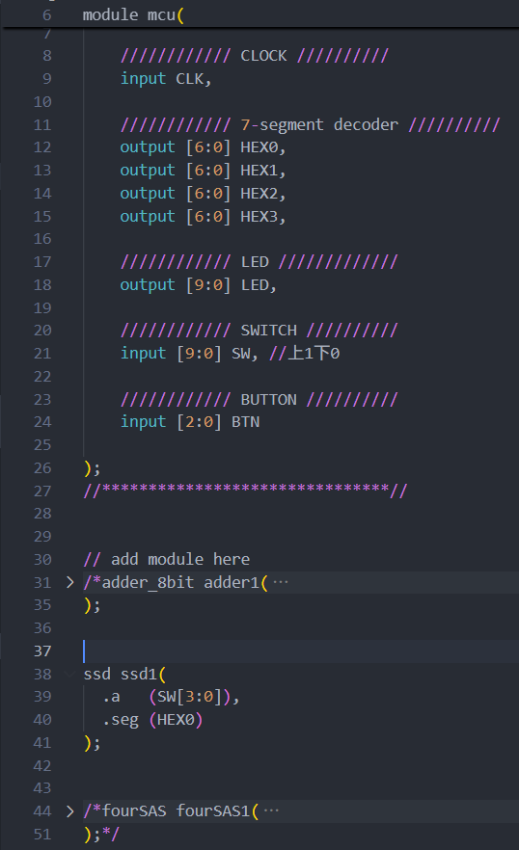
Waveform and Result Screenshot
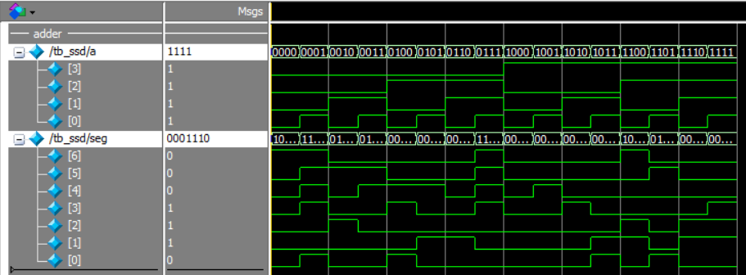
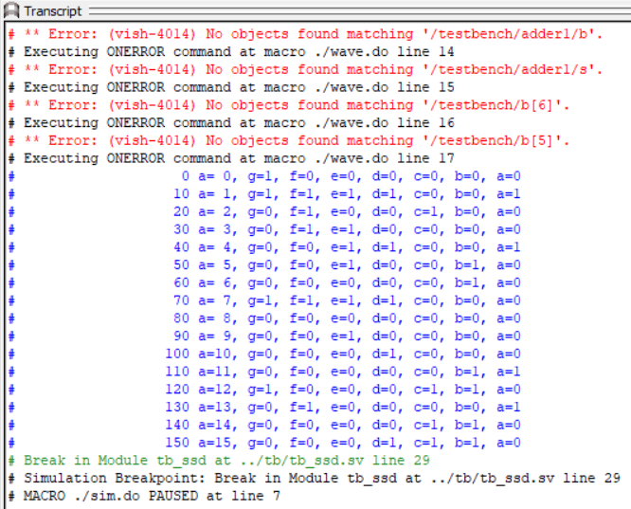

- Lab 7-2：

Main Code Screenshot
fourAS.sv:
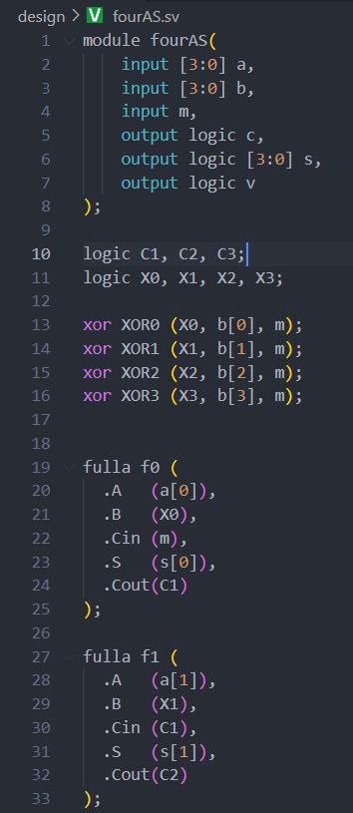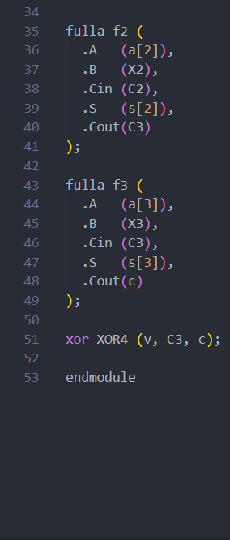
fulla.sv:
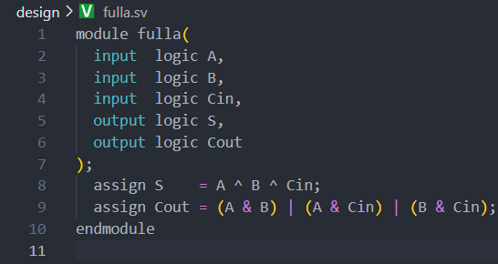
Testbench Screenshot
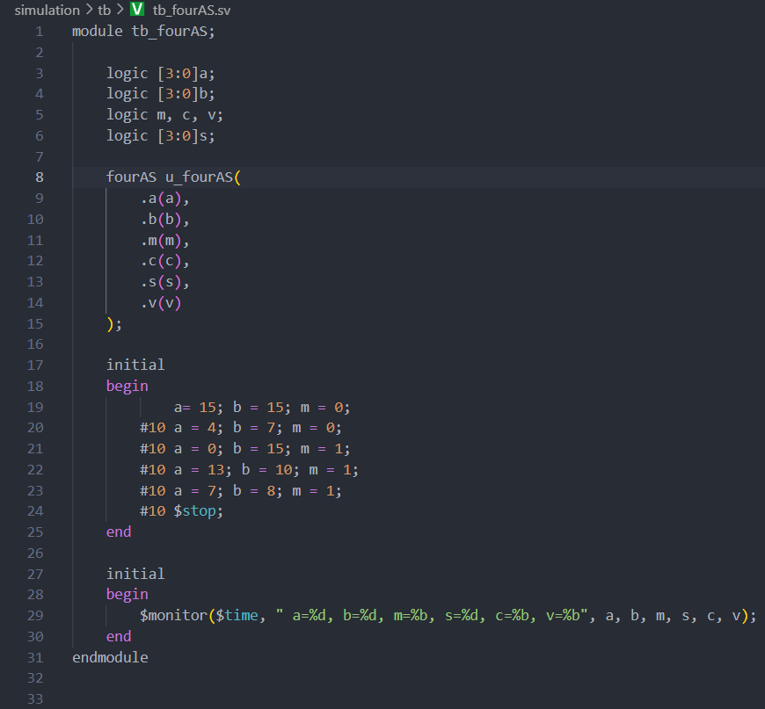
Waveform and Result Screenshot
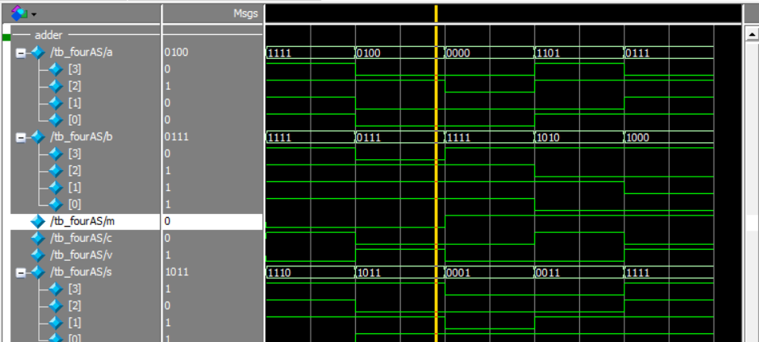
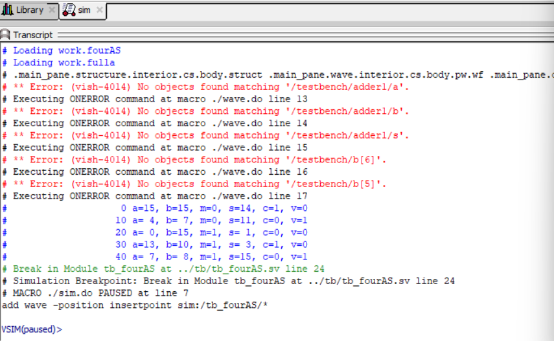

- Lab 7-3：

Main Code Screenshot
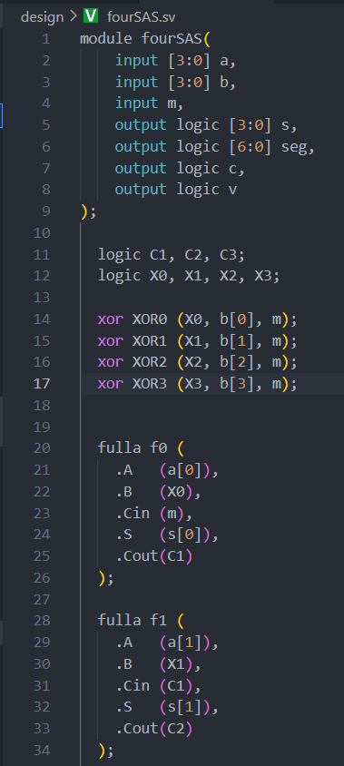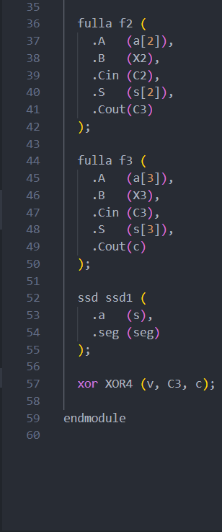
The fulla is same as the Lab 7-2.
The ssd is Lab 7-1.
Testbench Screenshot
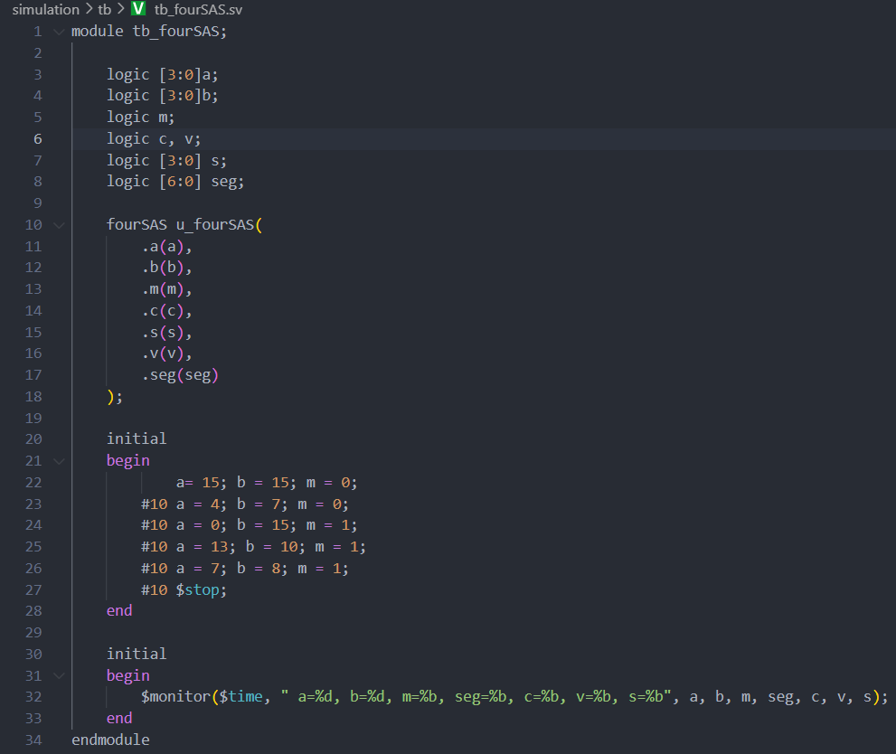
Mcu.sv Code Screenshot
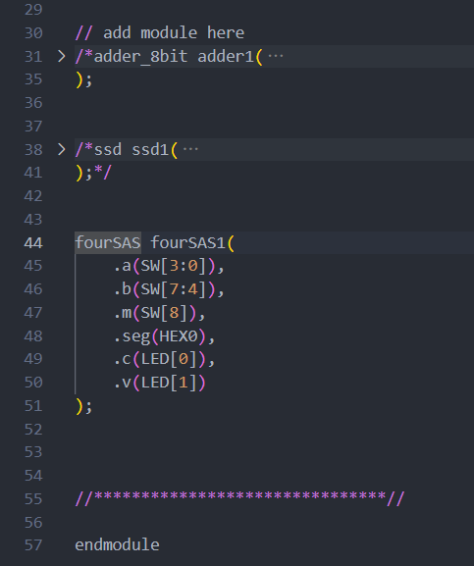
Waveform and Result Screenshot
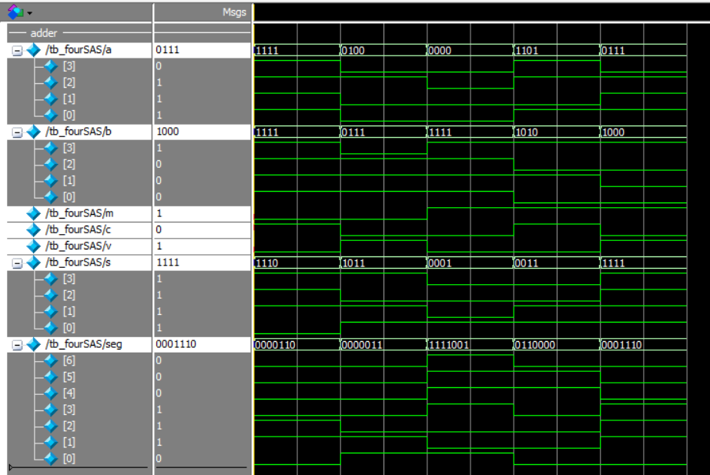
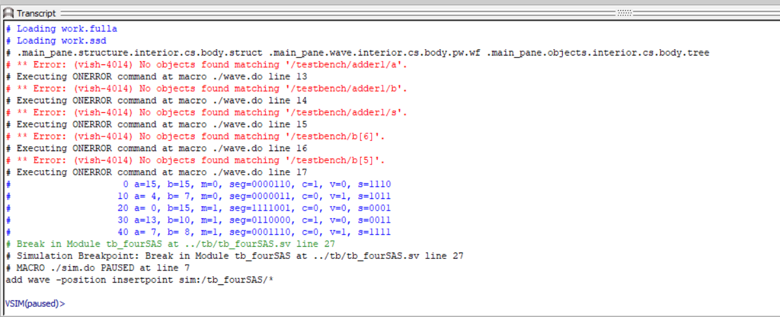

- Lab Summary and Reflection:
Summary:
In this week’s experiment, we employed Quartus and the Altera DE0 development board to design and simulate fundamental combinational logic circuits using SystemVerilog. First, we implemented a seven-segment display (SSD) decoder that translates a 4-bit binary input into the corresponding segment activation pattern to render hexadecimal digits on a common-anode SSD ​. Next, we developed a 4-bit adder/subtractor module capable of performing addition or subtraction based on a mode control signal, complete with overflow detection via a ‘v’ flag ​. Finally, these two modules were integrated so that arithmetic results could be simultaneously computed and displayed: binary operands entered via the DE0’s slide switches are processed by the adder/subtractor, and the resulting sum or difference is fed through the SSD decoder for real-time visualization ​.
Reflection:
Through this hands-on exercise, I deepened my understanding of mapping abstract Boolean expressions to physical hardware interfaces and the nuances of SystemVerilog’s assign statements for combinational logic. Working with ModelSim testbenches highlighted the importance of thorough stimulus verification and waveform inspection to catch edge-case behaviors, particularly in subtraction operations where two’s-complement logic can introduce subtle overflow conditions ​. Downloading the synthesized design to the DE0 board reinforced practical skills in pin-assignment constraints and timing analysis under real-world conditions. Moving forward, I aim to optimize my code for resource utilization and explore parameterized module designs to enhance reusability across similar combinational tasks.

